EDUGLYPH
RESEARCH ON DEEP LEARNING FOR ASL
Writer: Nguyen Le Thanh Hien
1. METHODOLOGY
1.1. Datasets Selection & Preprocessing
The foundation of the proposed gesture recognition model relies on a robust, highly varied image corpus to ensure accurate generalization across different hand anatomies, lighting conditions, and background environments. To achieve this, the primary dataset is synthesized by aggregating multiple open-source repositories.
Data Sourcing
The aggregated dataset incorporates both static alphabetic characters and dynamic conversational vocabulary. The primary sources include the "American Sign Language Dataset" (Thakur, 2019), which provides a strong foundational baseline for multi-class classification, and the "ASL Alphabet Dataset" (Sau, 2022), which introduces a broader collection of 29 classes, including space, clear, and nothing configurations. To supplement these foundational datasets and introduce numerical digits and specific vocabulary necessary for a classroom setting, localized datasets curated via Roboflow (specifically ASL-Alphabet-&-Numbers-1) are also integrated.
Dataset Name | Source / Author | Content Coverage | Application Purpose
American Sign Language Dataset | Kaggle (Thakur, 2019) | 26-class alphabet characters | Baseline feature extraction and static gesture training.
ASL Alphabet Dataset | Kaggle (Sau, 2022) | 29 classes (A-Z, space, clear, nothing) | Increasing background variance and environmental robustness.
ASL-Alphabet-&-Numbers-1 | Roboflow (Custom/Localized) | Numerical digits (0-9) and specific words (e.g., "hello", "help", "right", "thanks") | Expanding the model's vocabulary for real-time classroom interactions.

Table 1: Summary of Aggregated ASL Datasets
Data Processing & Filtering
Raw image data cannot be directly fed into the proposed multilayer perceptron (MLP); it requires rigorous preprocessing to extract meaningful spatial features. The preprocessing pipeline is executed as follows:
- Label Normalization: The diverse string annotations from the distinct datasets are aggregated and standardized into a uniform integer-based categorization system ranging from 0 to 39. This establishes a total of 40 distinct classification classes: 26 alphabetic characters, 10 numerical digits, and 4 specific vocabulary words.
- Landmark Extraction: Instead of processing raw pixel data via Convolutional Neural Networks (CNNs), this methodology utilizes Google MediaPipe (Bongini et al., 2020) to extract precise skeletal representations of the hand. For each input image, MediaPipe identifies 21 3D spatial landmarks (x, y, z coordinates).
- Data Filtering: A strict filtering mechanism is applied during the extraction phase. Any image frame where the MediaPipe algorithm fails to detect a complete hand structure with high confidence is automatically discarded. This ensures that the neural network is only trained on valid, high-fidelity skeletal data, preventing noise from corrupting the learning process.
Data Splitting
Following the extraction and filtering of the 3D landmark coordinates, the processed numerical dataset is structured into a one-dimensional array format suitable for the Sequential neural network. The aggregated valid data is then partitioned into distinct subsets for Training, Validation, and Testing to evaluate the model's predictive capabilities properly. The final testing subset, which is isolated from the training phase to provide an unbiased evaluation of the model's real-world generalization, comprises 48,023 samples across the 40 established classes.
1.2. Deep Learning Pipeline
To process the pre-filtered datasets and perform real-time gesture classification, the methodology employs a hybrid pipeline that combines computer vision-based spatial extraction with a Multilayer Perceptron (MLP) architecture, as shown in Figure 1.
Feature Extraction via MediaPipe
Instead of utilizing Convolutional Neural Networks (CNNs) to process raw pixel arrays—which are computationally expensive and highly susceptible to background noise—this architecture utilizes the Google MediaPipe framework for spatial feature extraction (Bongini et al., 2020). MediaPipe maps the topology of the hand, outputting 21 distinct 3D landmarks. Each landmark contains an , , and coordinate, resulting in a flattened 1D array of 63 precise spatial features per frame. This significant dimensionality reduction allows the model to focus purely on the structural geometry of the gesture, improving inference speed and making it highly suitable for web-based integration (El-Rushaidat et al., 2026).
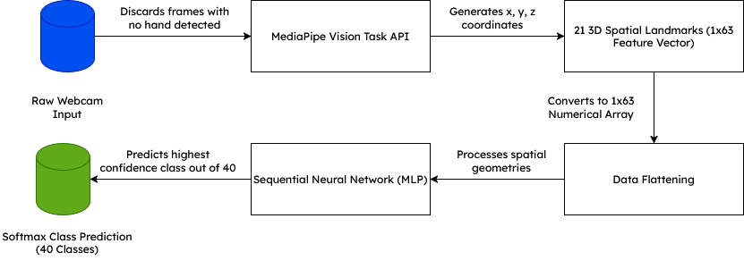
Figure 1. Proposed Deep Learning Pipeline
Neural Network Architecture (Layer Structure)
The classification engine is built using the Keras Sequential API. Because the input data has already been distilled into 63 highly contextual spatial coordinates, a dense, fully connected MLP is highly efficient (Subramanian et al., 2024). The internal structure of the model in Figure 2 relies on three primary layer types to achieve high accuracy while mitigating overfitting:
- Dense (Fully Connected) Layers: These layers act as the core learning mechanism. Using the Rectified Linear Unit (ReLU) activation function, they identify non-linear relationships between the 21 finger joints, learning how specific joint angles and distances correlate to specific ASL characters.
- Batch Normalization Layers: Placed immediately after Dense layers, Batch Normalization standardizes the inputs to the next layer for each mini-batch. This stabilizes the learning process, reduces internal covariate shift, and allows the network to converge much faster during the training phase.
- Dropout Layers: To ensure the model generalizes well to unseen hands rather than memorizing the training data, Dropout layers (Srivastava et al., 2014) randomly deactivate a percentage (e.g., 20% or 50%) of neurons during each training epoch.
- Softmax Output: The final Dense layer contains exactly 40 neurons (matching the 40 ASL classes) and utilizes the Softmax activation function to convert the network's raw outputs into a normalized probability distribution ranging from 0 to 1.
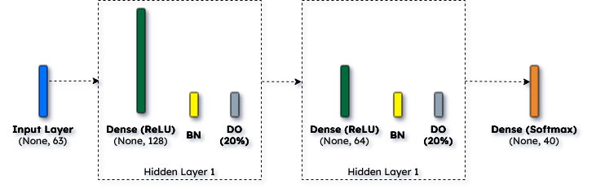
Figure 2. Proposed Deep Learning Layer Structure
2. SYSTEM ARCHITECTURE & IMPLEMENTATION
2.1. Eduglyph Architecture Overview
The Eduglyph platform, as shown in Figure 3 is engineered as a real-time, interactive classroom environment tailored specifically for American Sign Language (ASL) instruction. The system architecture follows a decoupled client-server model, separating the user interface and peer-to-peer video streaming from the computationally intensive AI inference tasks.
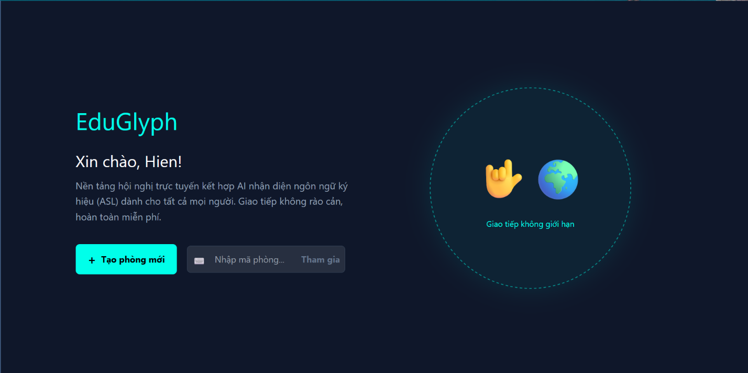
Figure 3. EduGlyph’s Home Page Interface
Frontend Interface (React.js)
The client-side application is developed using React.js. Given the target demographic—which includes both ASL learners and potentially older instructors—the User Interface (UI) is designed with high-contrast elements, clear typography, and an intuitive layout.
- Authentication: The system includes modular Register.js and Login.js components that differentiate between standard students and instructors (users over the age of 22 are flagged as teachers, granting them meeting control privileges).
- Room Management: The Home.js component allows users to generate unique, 9-character alphanumeric room codes or join existing sessions.
Real-Time Communication (PeerJS & WebRTC)
To facilitate a live classroom environment without placing excessive bandwidth load on a central server, the application utilizes WebRTC (Web Real-Time Communication) integrated via the PeerJS library (Lugaresi, 2026).
- When a user joins a room via the MeetingRoom.js component, PeerJS establishes direct, peer-to-peer video and audio connections between all participants.
- This decentralized approach ensures low-latency video streaming, which is critical for observing fast-paced sign language gestures without stutter or lag.
Backend Server (Flask & Socket.IO)
The backend architecture is built on Python using the Flask framework. It serves two primary functions: managing application state and executing the AI inference model.
- Signaling Server: The backend acts as a signaling server using Flask-SocketIO (Grinberg, 2018). It orchestrates the initial handshake between peers, manages room states (join/leave events), and broadcasts secondary data streams such as text chat messages and synchronized whiteboard drawing coordinates (app.py).
- Microphone Integration: The Microphone.js component utilizes the native Web Speech API (MDN Web Docs, 2026b) for speech-to-text functionality, allowing spoken words to be transcribed and broadcast to the room alongside the ASL translations.
Live Inference Workflow
The core functionality of Eduglyph is the real-time translation of ASL gestures into text. As shown in Figure 4, this is achieved through a continuous communication loop between the React frontend and the Flask backend.
- Frame Capture: The CameraFeed.js component accesses the user's webcam. To optimize network performance and server load, it does not send a continuous video stream. Instead, it captures a snapshot of the video feed every 300 milliseconds.
- Data Transmission: These snapshots are encoded into Base64 strings and transmitted to the Flask server via an active Socket.IO connection.
- Backend Processing: Upon receiving a frame, app.py decodes the Base64 string back into a NumPy image array. It then passes this array through the MediaPipe pipeline to extract the 3D landmarks.
- Model Execution: If valid hands are detected, the landmarks are flattened and fed into the trained Keras Sequential model (the MLP discussed in Section 1.2). The model outputs a prediction.
- Broadcast Subtitles: The predicted class (e.g., "HELLO", "A", "RIGHT") is immediately emitted back to the specific room via Socket.IO. The frontend receives this string and renders it as an overlay subtitle on the corresponding user's video tile within the UI.
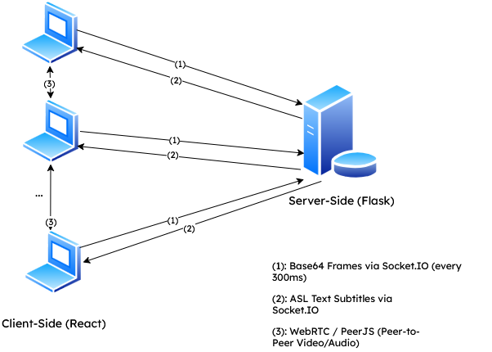
Figure 4. Web Application Workflow Diagram
3. REFERENCES
Bongini, P., Zhang, F., Bazarevsky, V., Vakunov, A., Tkachenka, A., Sung, G., Chuo, C.L. and Grundmann, M. (2020) Mediapipe Hands: On-device Real-time Hand Tracking. arXiv preprint [online]. Available from: https://arxiv.org/abs/2006.10214 [Accessed 20 March 2026].
El-Rushaidat, D., Al-Khateeb, H. and Al-Qassas, R. (2026) Video-Based Arabic Sign Language Recognition with Mediapipe and Deep Learning Techniques. Preprints.org [online]. Available from: https://doi.org/10.20944/preprints202603.0913.v1 [Accessed 20 March 2026].
Grinberg, M. (2018) Flask-SocketIO Documentation [online]. Flask-SocketIO. Available from: https://flask-socketio.readthedocs.io/en/latest/ [Accessed 19 March 2026].
Lugaresi, M. (2020) Building a Video Chat App with Node.js + Socket.io + WebRTC [online]. freeCodeCamp. Available from: https://www.freecodecamp.org/news/building-a-video-chat-app-with-node-js-socket-io-webrtc-26f46b213017/ [Accessed 19 March 2026].
MDN Web Docs (2026a) WebRTC API [online]. Mozilla. Available from: https://developer.mozilla.org/en-US/docs/Web/API/WebRTC_API [Accessed 19 March 2026].
MDN Web Docs (2026b) Web Speech API [online]. Mozilla. Available from: https://developer.mozilla.org/en-US/docs/Web/API/Web_Speech_API [Accessed 19 March 2026].
PeerJS (2026) PeerJS: Simple peer-to-peer with WebRTC [online]. PeerJS. Available from: https://peerjs.com/ [Accessed 19 March 2026].
Sau, D. (2022) ASL (American Sign Language) Alphabet Dataset [online]. Kaggle. Available from: https://www.kaggle.com/datasets/debashishsau/aslamerican-sign-language-alphabet-dataset [Accessed 16 February 2026].
Srivastava, N., Hinton, G., Krizhevsky, A., Sutskever, I. and Salakhutdinov, R. (2014) Dropout: A Simple Way to Prevent Neural Networks from Overfitting. Journal of Machine Learning Research [online], 15 (1), pp. 1929-1958. Available from: https://jmlr.org/papers/v15/srivastava14a.html [Accessed 21 March 2026].
Subramanian, B., Sriram, R., Kirthika, M. and Gokul, P. (2024) An integrated mediapipe-optimized GRU model for Indian sign language recognition. Scientific Reports [online], 12. Available from: https://pmc.ncbi.nlm.nih.gov/articles/PMC9279358/ [Accessed 20 March 2026].
Thakur, A. (2019) American Sign Language Dataset [online]. Kaggle. Available from: https://www.kaggle.com/datasets/ayuraj/asl-dataset [Accessed 15 February 2026].

